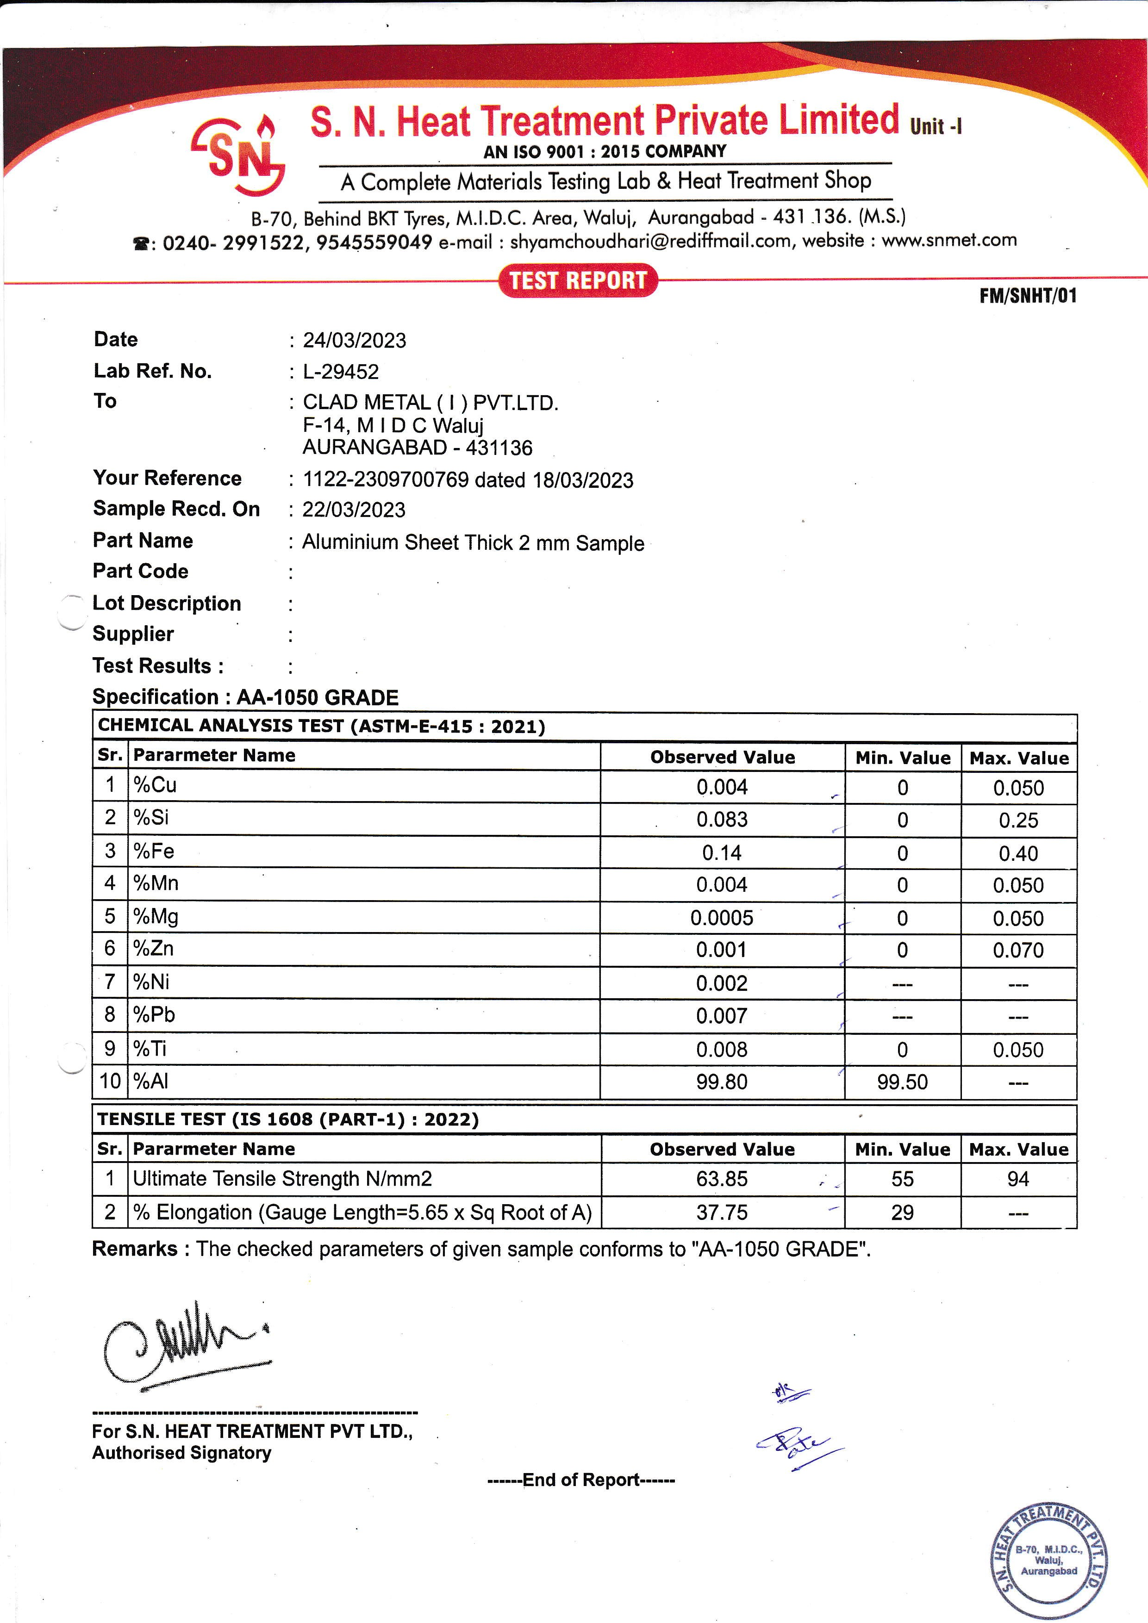

|  |  |  |  |  |  |
| --- | --- | --- | --- | --- | --- |
| **Date :** 24/04/2024 | | | | | |
| **Lab Ref.No :** L-07232 | | | | | |
| **To :** CLAD METAL ( I ) PVT .LTD | | | | | |
| F-14 M I D C Waluj | | | | | |
| AURANGABAD - 431136 | | | | | |
| **Your Reference :** 06342 dated 21/04/2024 | | | | | |
| **Sample Recd.On :** 21/04/2024 | | | | | |
| **Part Name :** Al Foil Size 0.15 X 200 | | | | | |
| **Part Code :** | | | | | |
| **Lot Description :** | | | | | |
| **Supplier :** | | | | | |
| **Test Results :** | | | | | |
| **Specification : 1100 H14 GRADE** | |  |  |  | |
| **CHEMICAL ANALYSIS TEST (ASTM-E-1251 : 2017)** | | | | | |
| **Sr.** | **Parameter Name** | **Observed Value** | **Min.Value** | **Max.Value** | |
| 1 | % Si + Fe | 0.54 | -- | 0.95 | |
| 2 | %Cu | 0.036 | -- | 0.05-0.20 | |
| 3 | %Mn | 0.001 | -- | 0.05 | |
| 4 | %Mg | 0.002 | -- | -- | |
| 5 | %Zn | 0.041 | -- | 0.1 | |
| 6 | %Ti | 0.087 | -- | -- | |
| 7 | %Al | 99.2 | 99.00 | -- | |
|  |  |  |  |  | |
| **TENSILE TEST (IS 1608)** | | | | | |
| **Sr.** | **Parameter Name** | **Observed Value** | **Min.Value** | | **Max.Value** |
| 1 | Ultimate Tensile Strength N/mm2 | 137 | 110 | | 145 |
| 2 | %Elongation (Gauge Length = 5.65 X Sq of CS Area) | 4.2 | 4% | | -- |
| **Remarks:** The Checked parameters of given sample conforms to '' 1100 H14 GRADE ''. | | | |  | |

13/02/2023

L-29467

CLAD METAL ( I ) PVT.LTD.

F-14, M I D C Waluj

AURANGABA – 431136

1122-2309700637 dated 07/02/2023

07/02/2023

Aluminum sheet thick 2 mm Sample